1)

Time 0:

This is the initial state where they all are going to send their own id

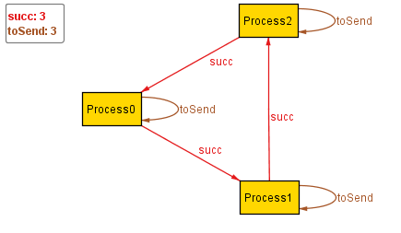

Time 1:

Process1 now wants to send Process 2 since it is higher

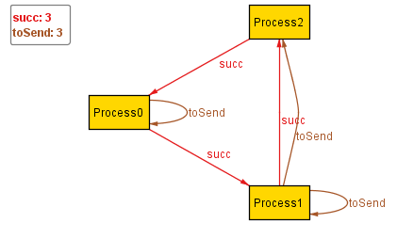

Time 2

Process0 now wants to send process 2

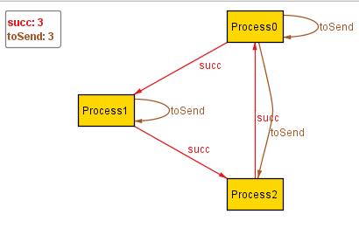

Time 3:

Process2 is now elected since it received itself

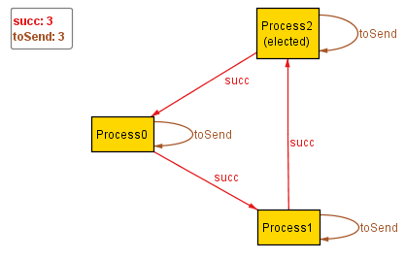

2)

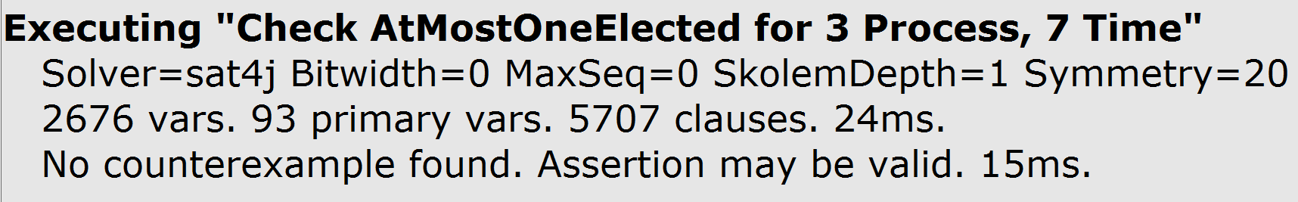

3)

AtLeastOneElectedWithAnIssue does not require progress to be made with each step. Processes are allowed to skip steps as much as they want, so nothing will ever be accomplished.

4)

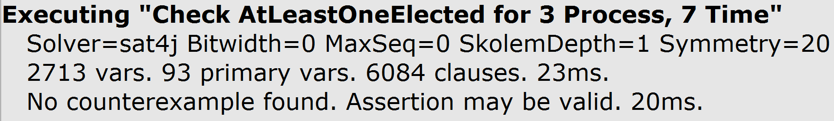

This is valid since their assertion requires progress to be made for each step in time.

5)

Not getting a new instance means that there is no way to go through 13 steps without repeating a state. This is an upper bound on how many periods that we will need to go through before we return to a state.

**LAB**

Q2:

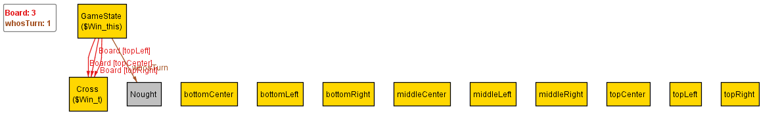

|  |  |  |
| --- | --- | --- |
| X | X | X |
|  |  |  |
|  |  |  |

Q3:

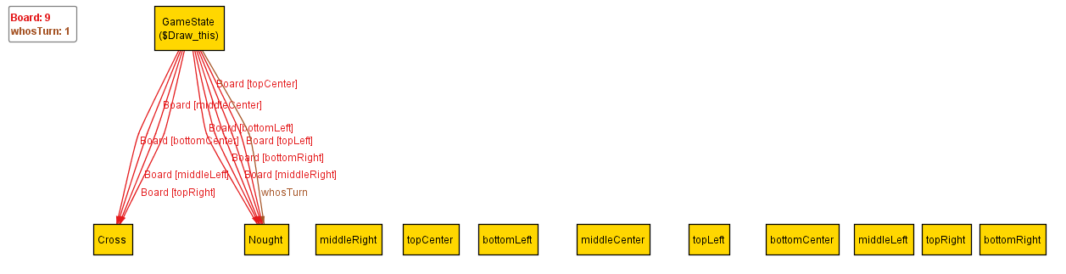

|  |  |  |
| --- | --- | --- |
| o | o | x |
| x | x | o |
| o | x | o |

Q8:

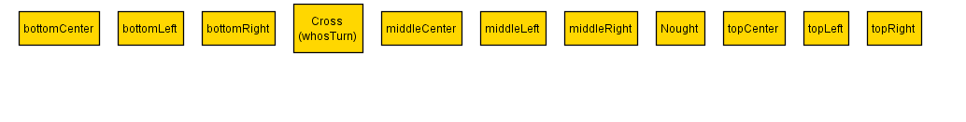

|  |  |  |
| --- | --- | --- |
|  |  |  |
|  |  |  |
|  |  |  |

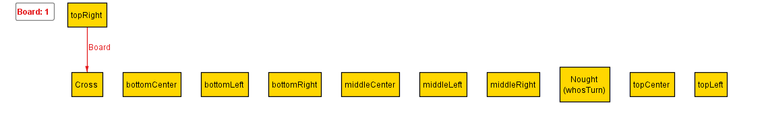

|  |  |  |
| --- | --- | --- |
|  |  | X |
|  |  |  |
|  |  |  |

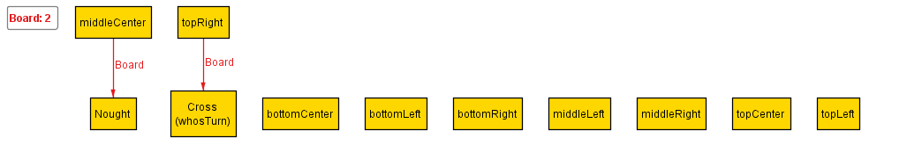

|  |  |  |
| --- | --- | --- |
|  |  | X |
|  | O |  |
|  |  |  |

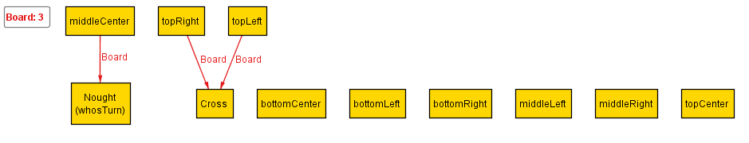

|  |  |  |
| --- | --- | --- |
| X |  | X |
|  | O |  |
|  |  |  |

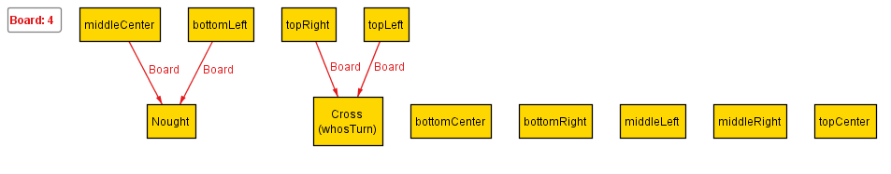

|  |  |  |
| --- | --- | --- |
| X |  | X |
|  | O |  |
| O |  |  |

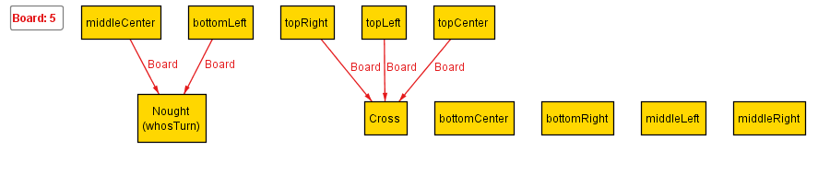

|  |  |  |
| --- | --- | --- |
| X | X | X |
|  | O |  |
| O |  |  |

Q9:



|  |  |  |
| --- | --- | --- |
|  |  |  |
|  |  |  |
|  |  |  |

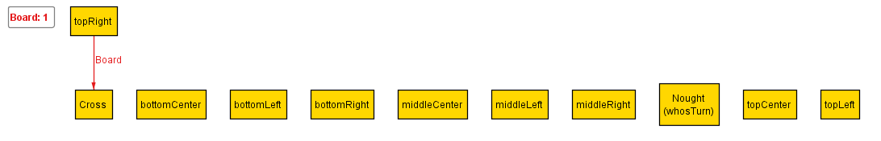

|  |  |  |
| --- | --- | --- |
|  |  | X |
|  |  |  |
|  |  |  |

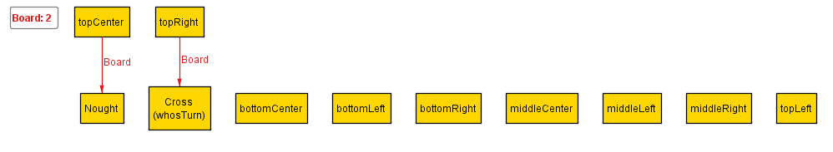

|  |  |  |
| --- | --- | --- |
|  | O | X |
|  |  |  |
|  |  |  |

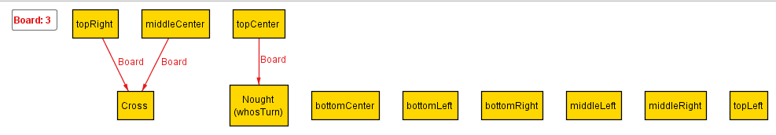

|  |  |  |
| --- | --- | --- |
|  | O | X |
|  | X |  |
|  |  |  |

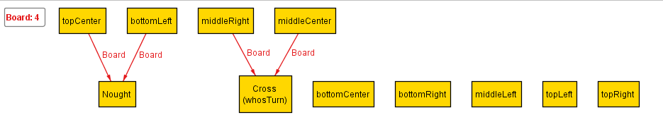

|  |  |  |
| --- | --- | --- |
|  | O | X |
|  | X |  |
| O |  |  |

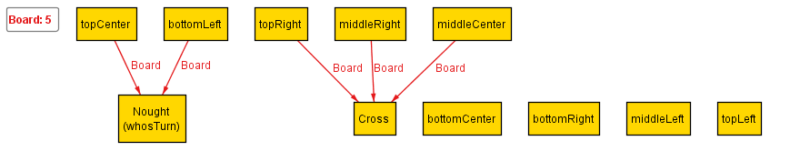

|  |  |  |
| --- | --- | --- |
|  | O | X |
|  | X | X |
| O |  |  |

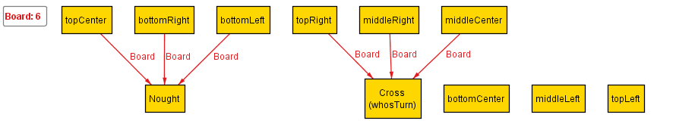

|  |  |  |
| --- | --- | --- |
|  | O | X |
|  | X | X |
| O |  | O |

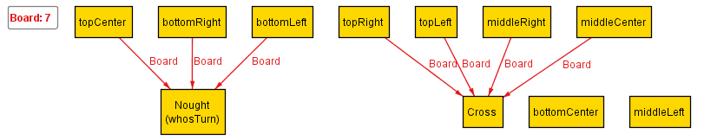

|  |  |  |
| --- | --- | --- |
| X | O | X |
|  | X | X |
| O |  | O |

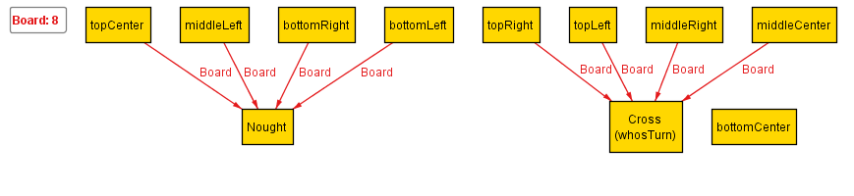

|  |  |  |
| --- | --- | --- |
| X | O | X |
| O | X | X |
| O |  | O |

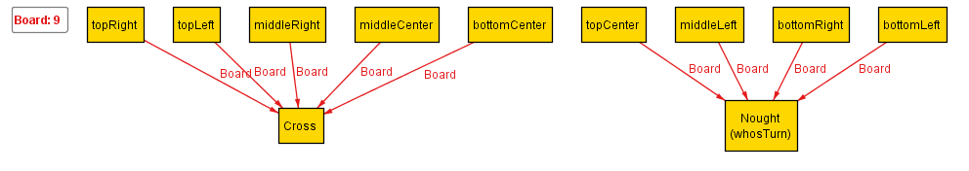

|  |  |  |
| --- | --- | --- |
| X | O | X |
| O | X | X |
| O | X | O |